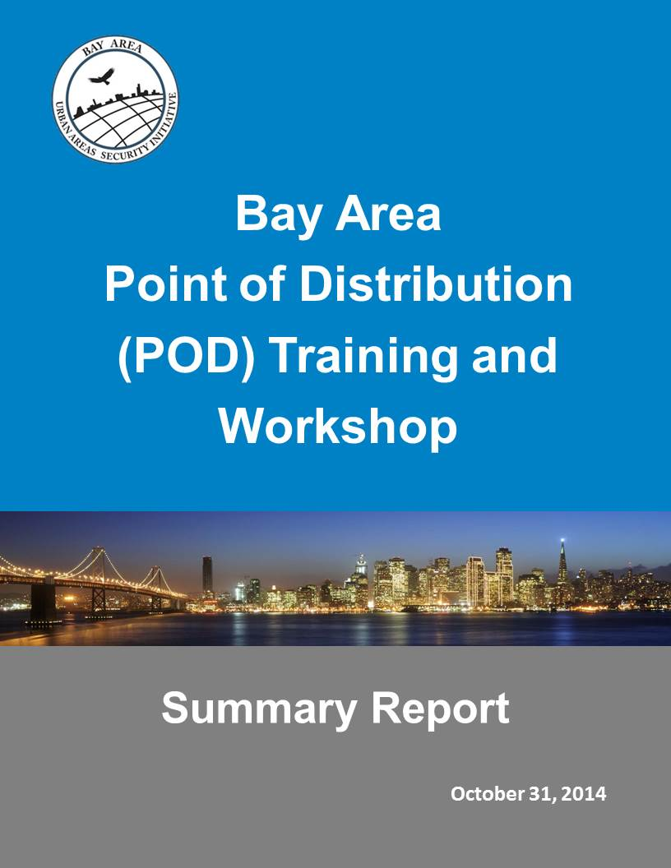

City of Los Angeles

POD Seminar Report

March 18, 2014

This document provides only the tools available for local jurisdictions to use in continued planning for points of distribution. The complete summary report is not available for public download. For more information or to request the complete workshop summary report, please contact:

Corinne Bartshire, AICP, CFM  
Regional Project Manager  
Bay Area Urban Areas Security Initiative   
711 Van Ness Avenue #420  
San Francisco, CA 94102  
[Corinne.Bartshire@sfgov.org](mailto:Corinne.Bartshire@sfgov.org)   
415-353-5234 (desk)  
415-861-9005 (cell)

APPENDIX B: POD INFO Template

|  |  |  |
| --- | --- | --- |
| ***The following template is provided to assist Operational Areas and other local jurisdictions in compiling a list of potential POD sites for submittal to Cal OES and FEMA Region IX.*** | | |
| **[ NAME ] County Operational Area Logistics Staging Areas (LSA) and Logistics Points of Distribution (POD) Locations** | | |
| **Logistics Staging Area** | **City** | **POD type and Location** |
| [NAME] (i.e. North, South, Central) Logistics Staging Area (LSA)  [ Insert LSA Address ] | City Name 1 | **Example: Type III Vehicular POD**   * Facility Name, Street Address, Zip * Facility Name 2, Street Address, Zip |
| City Name 2 | **Example: Type II Pedestrian POD**   * Facility Name, Street Address, Zip |
| City Name 3 | **Example: Type I Vehicular POD**   * Facility Name, Street Address, Zip |
| [NAME] Logistics Staging Area (LSA) [ Insert LSA Address ] |  |  |

| **POD Type** | **Persons Served per Day** |
| --- | --- |
| **Type I POD (Vehicular or Pedestrian) - 250 ft. x 500 ft**  Requires a staff of 78 per day  Type I PODs are only used in large metro areas  Twelve loading points and four vehicle lanes are used | 20,000 |
| **Type II POD (Vehicular or Pedestrian) - 250 ft. x 300 ft.**  Requires a staff of 34 per day  Six loading points and two vehicle lanes are used | 10,000 |
| **Type III POD (Vehicular) - 150 ft. x 300 ft.**  Requires a staff of 19 per day  Three loading points and one vehicle lane are used | 5,000 |
| Source: POD Plan, Table H.4.1, developed by the NY-NJ-CT-PA RCPGP Regional Logistics Program POD = Point of Distribution | |

**Figure B-1: POD Distribution Modes**

The following graphic is provided to show that the local emergency management agency is the primary authority for activating, operations and demobilization of POD sites. This should all be coordinated through the local emergency operations center in coordination and communication with regional and Federal partners. The actual process may look different based on the event, damage and capability of the Bay Area Region, OAs, cities and local entities. Commodities can and should come from anywhere the affected operational area(s) request them from, not simply a Federal centric delivery approach. Federal agencies will compliment local structures in place and support commodities needs as requested by the local jurisdiction.



*Reference: FEMA IS-26 Guide to Points of Distribution*

APPENDIX D: Event Scenario

***Scenario excerpts are from the Regional Catastrophic Earthquake Plans (2008).***

A catastrophic earthquake in the Bay Area will immediately overwhelm local, regional, and State emergency response capabilities. The region will need massive, rapid support from the Federal Government, other local governments in California, other states, the private sector and voluntary organizations. The effectiveness of the region’s response will affect the long-term recovery of the region’s communities and economy.

The Regional Catastrophic Earthquake Plans (Annexes to the San Francisco Bay Area Regional Emergency Coordination Plan) are based upon a catastrophic earthquake scenario; the earthquake scenario is a recurrence of the 1906 earthquake on the northern segment of the San Andreas Fault, an M 7.9 earthquake.

Damage is catastrophic in the areas that experience shaking intensities of Modified Mercalli (MM) IX and X and high or very high levels, of susceptibility for liquefaction (i.e., areas adjacent to the fault in Marin, San Francisco, San Mateo, Santa Clara, Santa Cruz, and Sonoma counties). Central Valley counties such as Sacramento and San Joaquin may be affected immediately by evacuations and other response actions. The rest of California and the Nation will be affected significantly by the large-scale response, effects on the population, economic disruption, and media attention.

Threats and hazards resulting from shaking, surface fault rupture, and liquefaction may include:

* Structural and nonstructural damage to buildings and infrastructure, including widespread collapse of buildings
* Widespread fires
* Subsidence and loss of soil-bearing capacity, particularly in areas of liquefaction
* Displacement along the San Andreas fault
* Widespread landslides
* Hazardous materials spills and incidents
* Dam/levee failure resulting in flooding
* Civil disorder
* Many residential, commercial, and industrial buildings are rendered uninhabitable
* All regional utilities and transportation networks significantly; large portions of the transportation infrastructure are damaged or destroyed
* Utility and water supply damage, even in areas with less extreme structural impacts, compounds the problem of housing people
* Most Internet connectivity, telephone lines, and cellular telephone systems are damaged, causing communication difficulties throughout the region

The earthquake results in:

* Approximately 400,000 displaced households
* More than 300,000 people seeking shelter
* More than 1 million people who need transportation assistance
* 1.8 million households without potable water
* 7,000 fatalities
* 50 million tons of debris
* More than 1 million people requiring transportation assistance because of hazardous conditions or dislocation

|  |  |  |  |  |  |
| --- | --- | --- | --- | --- | --- |
| Table D.1. Number of households without potable water after the earthquake. | | | | | |
| County | Total  Households | Households without Potable Water Post-Event | | | |
| E+24 Hours | E+72 Hours | E+7 Days | E+30 Days |
| Alameda | 564,200 | 465,000 | 459,800 | 448,200 | 341,800 |
| Contra Costa | 384,600 | 105,700 | 85,700 | 45,600 | N/A |
| Marin | 105,300 | 56,300 | 48,600 | 29,300 | N/A |
| Monterey | 130,300 | N/A | N/A | N/A | N/A |
| Napa | 50,300 | 3,900 | <100 | 0 | 0 |
| San Benito | 17,300 | N/A | N/A | N/A | N/A |
| San Francisco | 358,900 | 340,100 | 336,400 | 326,100 | N/A |
| San Mateo | 268,000 | 236,900 | 234,300 | 228,100 | 149,700 |
| Santa Clara | 624,700 | 516,800 | 512,300 | 502,700 | 423,100 |
| Santa Cruz | 95,800 | 16,100 | 6,500 | <100 | <100 |
| Solano | 140,900 | 12,500 | 3,700 | <100 | <100 |
| Sonoma | 182,900 | 87,800 | 81,900 | 69,100 | <100 |
| Total | **2,923,200** | **1,841,100** | **1,769,200** | **1,649,400** | 914,900 |
| Source: HAZUS analysis conducted by URS in 2009. Estimates have been adjusted, by county, for population increases since 2000.  E = event  N/A = Not available (HAZUS results are unreliable) | | | | | |

*Reference: Regional Catastrophic Earthquake Mass Transportation/Evacuation Plan*

*Annex to the San Francisco Bay Area Regional Emergency Coordination Plan*

|  |  |  |  |  |  |
| --- | --- | --- | --- | --- | --- |
| Table D.2. Number of households without electricity after the earthquake. | | | | | |
| County | Total Households | Households without Electricity Post-Event | | | |
| E+24 Hours | E+72 Hours | E+7 Days | E+30 Days |
| Alameda | 564,200 | 23,600 | 13,700 | 5,400 | 1,200 |
| Contra Costa | 384,600 | 15,400 | 9,300 | 3,700 | 800 |
| Marin | 105,300 | 3,700 | 2,400 | 1,100 | 200 |
| Monterey | 130,300 | N/A | N/A | N/A | N/A |
| Napa | 50,300 | 2,000 | 1,200 | 500 | 100 |
| San Benito | 17,300 | N/A | N/A | N/A | N/A |
| San Francisco | 358,900 | 253,900 | 161,300 | 73,100 | 18,300 |
| San Mateo | 268,000 | 100,100 | 62,800 | 27,900 | 6,800 |
| Santa Clara | 624,700 | 57,100 | 34,300 | 14,400 | 3,400 |
| Santa Cruz | 95,800 | 15,500 | 9,600 | 3,900 | 800 |
| Solano | 140,900 | 5,600 | 3,200 | 1,400 | 300 |
| Sonoma | 182,900 | 60,000 | 40,400 | 19,700 | 5,000 |
| Total | **2,923,200** | **492,200** | **308,400** | **139,000** | 34,300 |
| Source: HAZUS analysis conducted by URS in 2009. Estimates have been adjusted, by county, for population increase since the year 2000. For Contra Costa, Napa, and Solano counties, the power loss is not accurately represented in HAZUS and is an average of losses for Alameda and Marin counties. HAZUS does not provide reliable results for Monterey and San Benito counties, but it can be assumed that there would be some power loss in these counties.  E = event occurrence N/A = Not available (HAZUS results are unreliable) | | | | | |

*Reference: Regional Catastrophic Earthquake Mass Transportation/Evacuation Plan*

*Annex to the San Francisco Bay Area Regional Emergency Coordination Plan*

| **Table D.3. Expected functionality of transbay bridges after the earthquake.** | | |
| --- | --- | --- |
| Bridge/Route | Condition | Description of Damage |
| Benicia–Martinez Bridge (I‑680) | Open | No major damage |
| Carquinez Bridge (I-80) | Open | No major damage |
| Richmond–San Rafael Bridge (I‑580) | Closed | Damage to access |
| Golden Gate Bridge (U.S 101) | Span open | Damage to access, particularly Doyle Drive in San Francisco |
| San Francisco–Oakland Bay Bridge (I‑80) | Closed | Damage to eastern span and access from San Francisco |
| San Mateo–Hayward Bridge (SR 92) | Span open | Damage to routes at western approach |
| Dumbarton Bridge (SR 84) | Closed | Damage to access from Newark and East Palo Alto |
| Source: CONPLAN (2008)  I = interstate  SR = State Route  U.S. = U.S. Highway | | |

|  |  |  |  |
| --- | --- | --- | --- |
| Table D.4. Estimated number of residents without potable water, number of those who seek shelter, and the number of those who need mass transportation assistance from E+72 hours to E+14 days. | | | |
| County | Residents without Potable Water | Number Seeking Shelter | Number Needing Mass Transportation Resources |
| Alameda | 1,142,900 | 114,200 | 57,100 |
| Contra Costa | 110,400 | 11,000 | 5,500 |
| Marin | 74,300 | 7,400 | 3,700 |
| Monterey | 0 | 0 | 0 |
| Napa | 0 | 0 | 0 |
| San Benito | 0 | 0 | 0 |
| San Francisco | 815,900 | 81,500 | 40,700 |
| San Mateo | 589,900 | 58,900 | 29,400 |
| Santa Clara | 1,292,500 | 129,200 | 64,600 |
| Santa Cruz | 0 | 0 | 0 |
| Solano | 0 | 0 | 0 |
| Sonoma | 177,000 | 17,700 | 8,800 |
| Total | **4,202,900** | **419,900** | 209,800 |
| Source: HAZUS and URS analysis (2009)  E = event | | | |

*Reference: Regional Catastrophic Earthquake Mass Transportation/Evacuation Plan*

*Annex to the San Francisco Bay Area Regional Emergency Coordination Plan*

|  |  |  |  |  |
| --- | --- | --- | --- | --- |
| Table D.5. Estimated number of displaced people who seek shelter, by county and for Oakland and San Jose. | | | | |
| County/City | 2009 Population | Displaced Households | Displaced People1 | Seeking  Shelter |
| Alameda | 1,556,500 | 95,400 | 257,600 | 67,300 |
| Contra Costa | 1,060,400 | 17,500 | 47,200 | 12,800 |
| Marin | 258,600 | 8,000 | 21,600 | 4,900 |
| Monterey | 431,900 | 2,300 | 6,300 | 2,300 |
| Napa | 137,600 | 3,500 | 9,300 | 2,400 |
| San Benito | 58,000 | 300 | 900 | 300 |
| San Francisco | 845,600 | 116,800 | 315,300 | 64,500 |
| San Mateo | 745,900 | 41,700 | 112,600 | 26,000 |
| Santa Clara | 1,857,600 | 97,300 | 262,600 | 64,700 |
| Santa Cruz | 268,600 | 3,600 | 9,800 | 2,900 |
| Solano | 426,300 | 3,400 | 9,200 | 2,600 |
| Sonoma | 486,600 | 14,500 | 39,200 | 9,400 |
| Regional totals | **8,133,600** | **404,300** | **1,091,600** | **260,100** |
| Homeless/Visitors | | | | **71,300** |
| Regional Total Seeking Shelter | | | | **331,400** |
| Oakland | 425,000 | 36,100 | 97,500 | 29,000 |
| San Jose | 1,006,700 | 52,900 | 142,800 | 39,900 |
| City totals | **1,431,700** | **99,000** | **329,300** | **69,900** |
| Source: HAZUS analysis conducted by URS (2009) and county sources  (2007 to 2009)  Number of displaced people based on 1 household = 2.7 people  HAZUS = Hazards U.S. | | | | |

*Reference:Regional Catastrophic Earthquake Mass Care and Shelter Plan*

*Annex to the San Francisco Bay Area Regional Emergency Coordination Plan*

|  |  |  |
| --- | --- | --- |
| Table D.6. Pre-earthquake shelter space capacity in the region, by county. | | |
| Counties | Number of Shelter Sites | Shelter Capacity |
| Alameda | 242 | 37,100 |
| Contra Costa | 162 | 13,500 |
| Marin | 128 | 13,900 |
| Monterey | 129 | 15,300 |
| Napa | 22 | 4,100 |
| San Benito | 8 | 300 |
| San Francisco | 82 | 33,000 |
| San Mateo | 181 | 27,100 |
| Santa Clara | 172 | 33,200 |
| Santa Cruz | 76 | 29,200 |
| Solano | 59 | 12,400 |
| Sonoma | 139 | 31,600 |
| Regional totals | **1,400** | **250,700** |
| Source: National Shelter System database, 2010 | | |

*Reference:Regional Catastrophic Earthquake Mass Care and Shelter Plan*

*Annex to the San Francisco Bay Area Regional Emergency Coordination Plan*

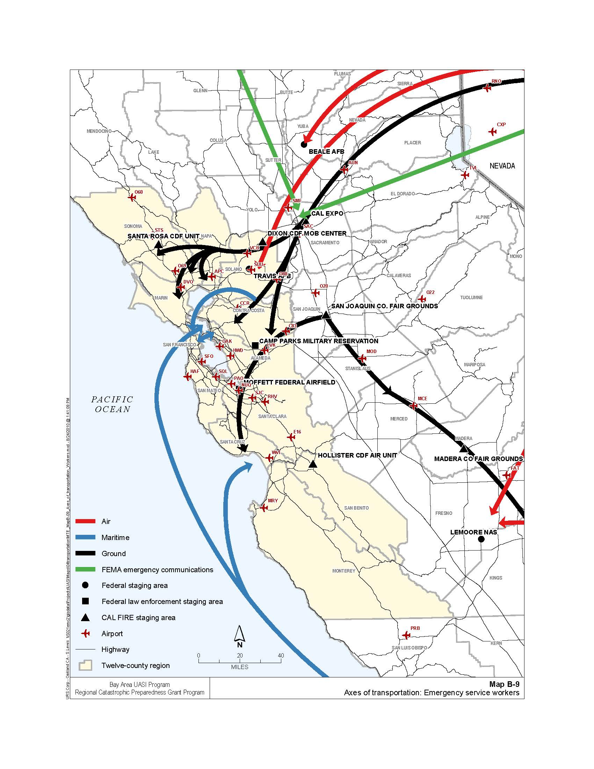APPENDIX e: Maps

*Reference: Regional Catastrophic Earthquake Mass Transportation/Evacuation Plan*

*Annex to the San Francisco Bay Area Regional Emergency Coordination Plan*

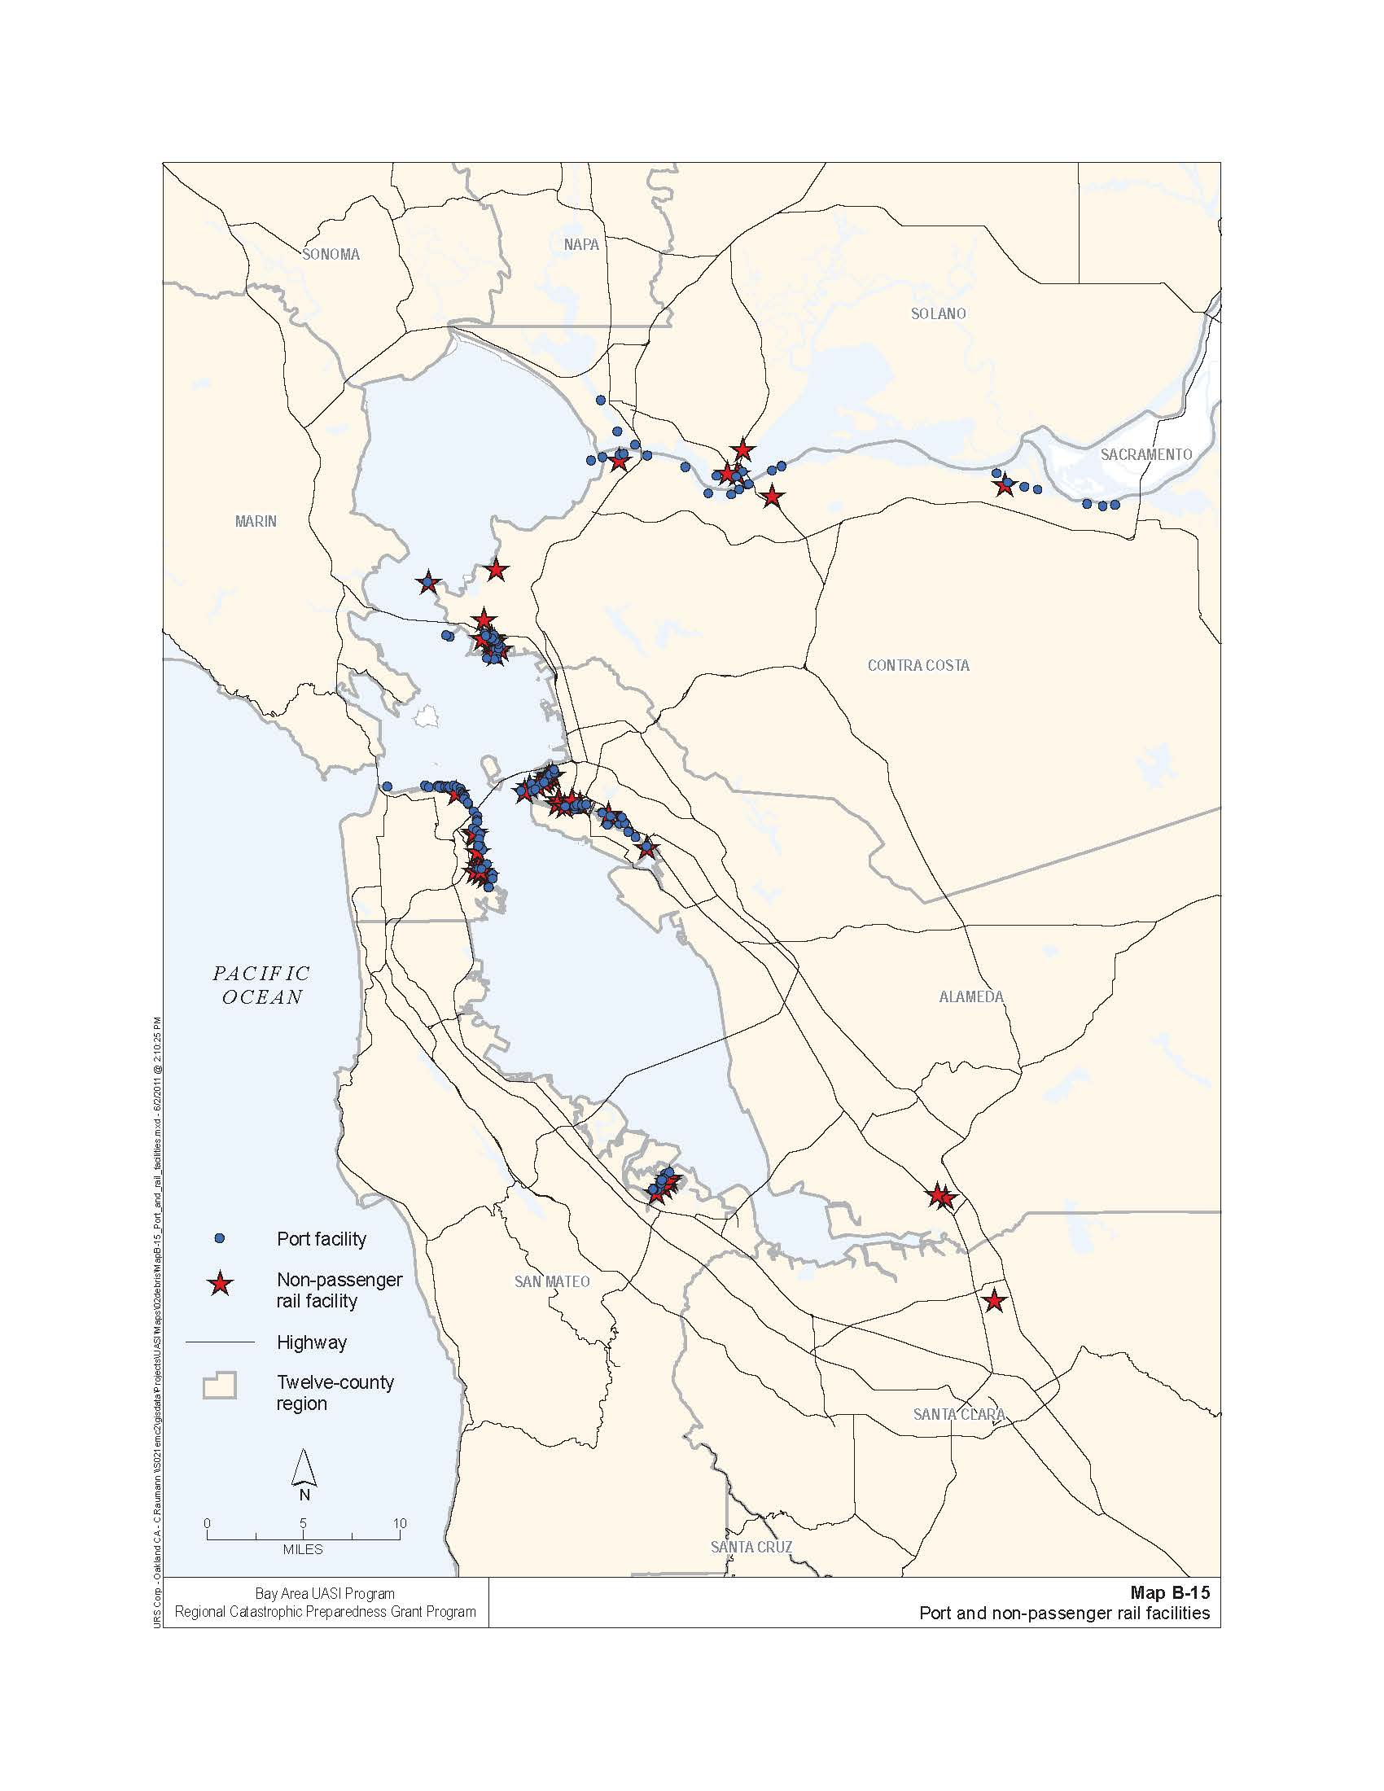

*Reference: Regional Catastrophic Earthquake Debris Removal Plan*

*Annex to the San Francisco Bay Area Regional Emergency Coordination Plan*

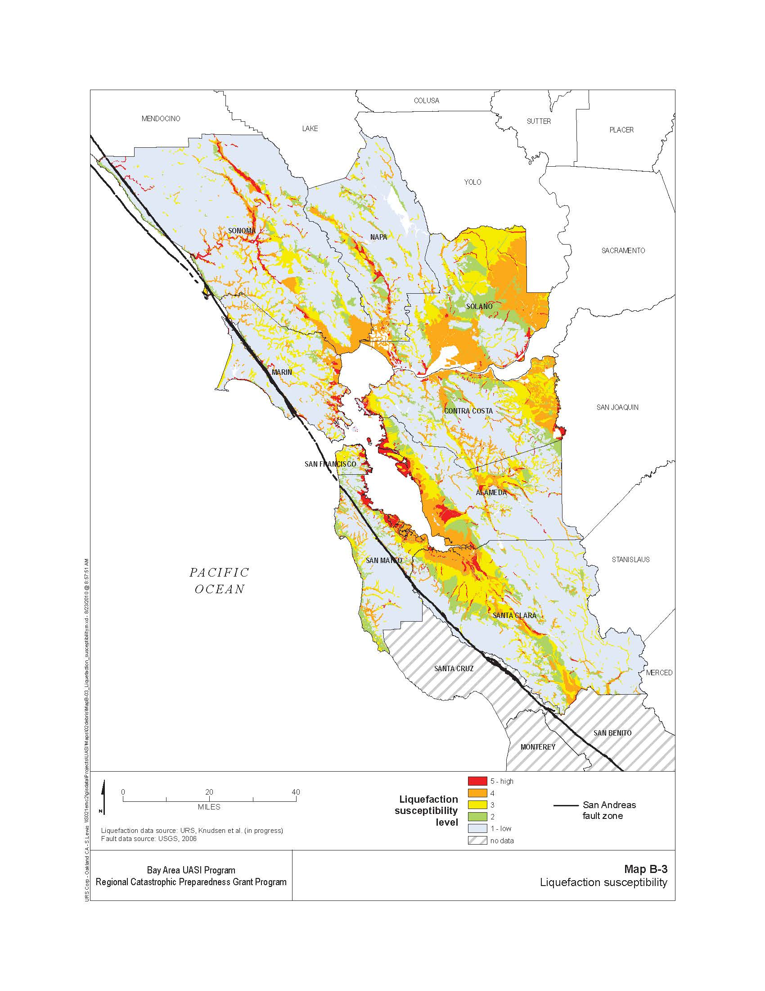

*Reference: Regional Catastrophic Earthquake Donations Management Plan*

*Annex to the San Francisco Bay Area Regional Emergency Coordination Plan*

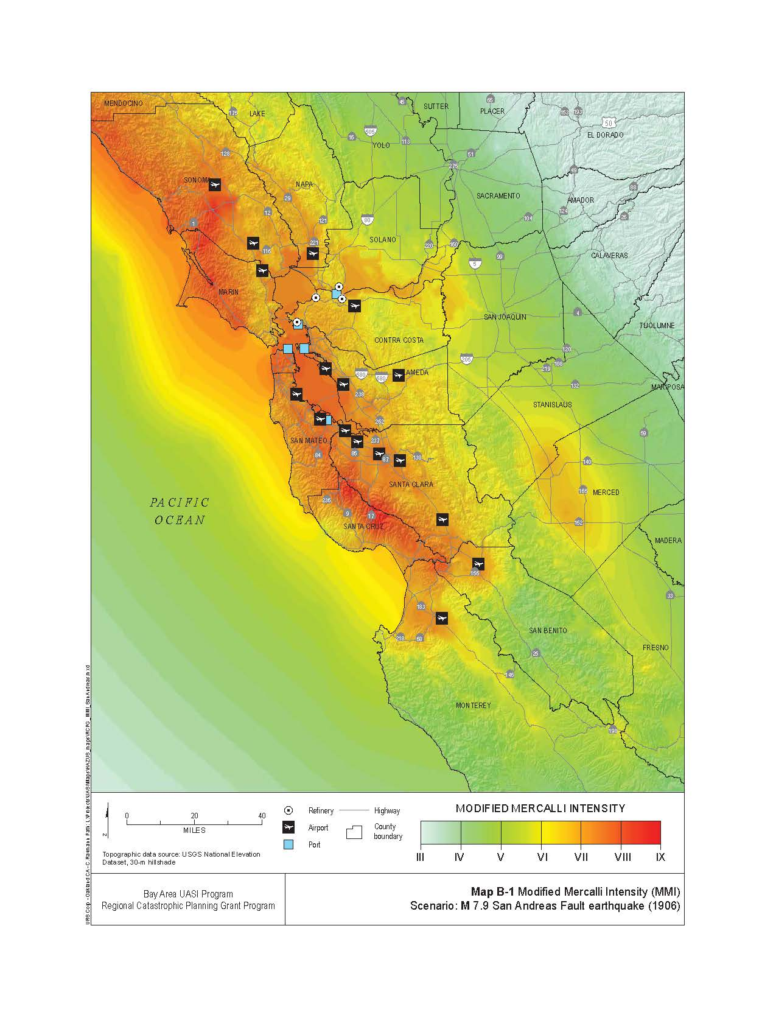

*Reference: Regional Catastrophic Earthquake Logistics Response Plan*

*Annex to the San Francisco Bay Area Regional Emergency Coordination Plan*

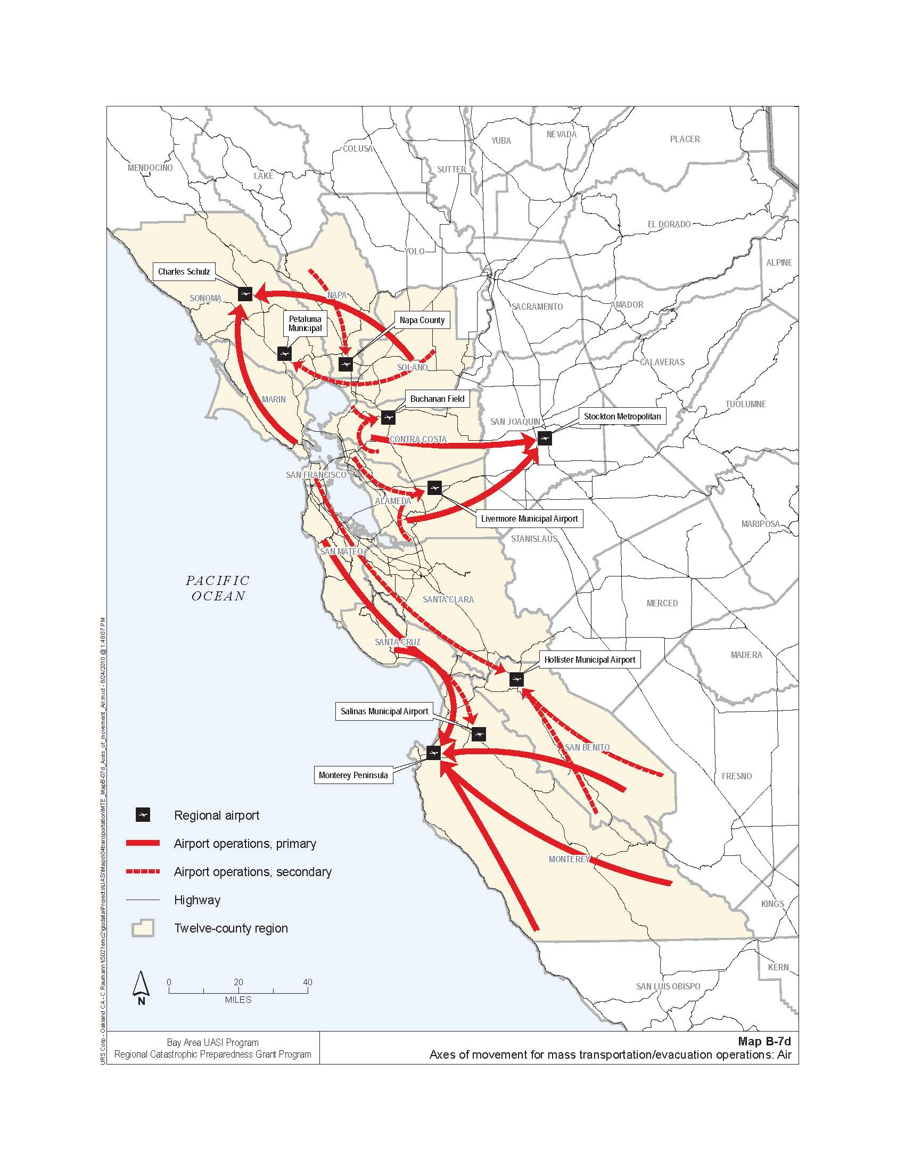

*Reference: Regional Catastrophic Earthquake Mass Transportation/Evacuation Plan*

*Annex to the San Francisco Bay Area Regional Emergency Coordination Plan*

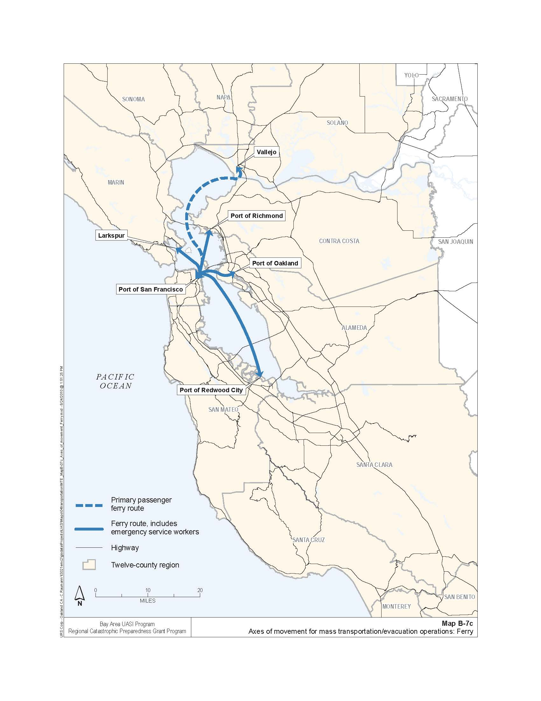

*Reference: Regional Catastrophic Earthquake Mass Transportation/Evacuation Plan*

*Annex to the San Francisco Bay Area Regional Emergency Coordination Plan*

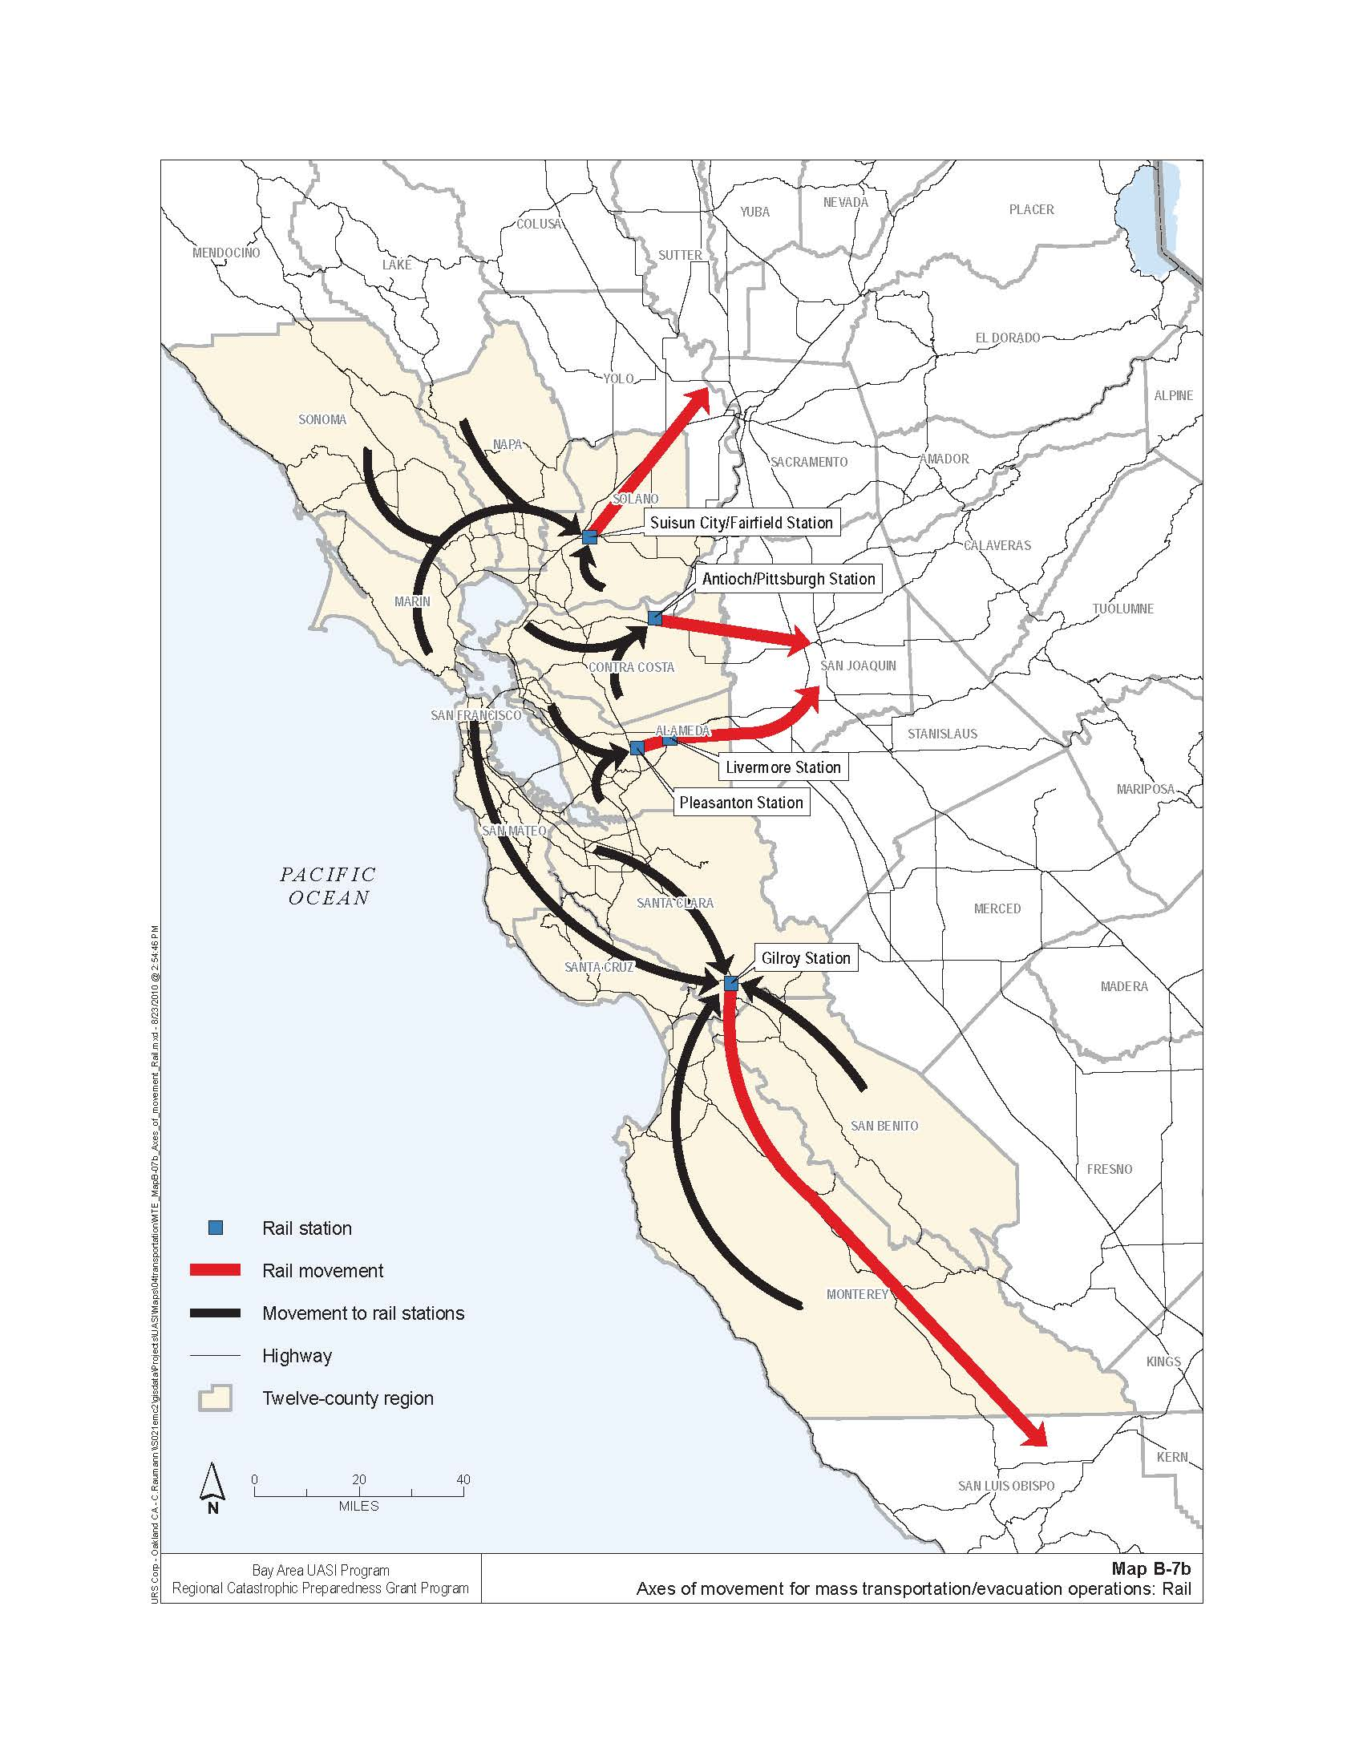

*Reference: Regional Catastrophic Earthquake Mass Transportation/Evacuation Plan*

*Annex to the San Francisco Bay Area Regional Emergency Coordination Plan*

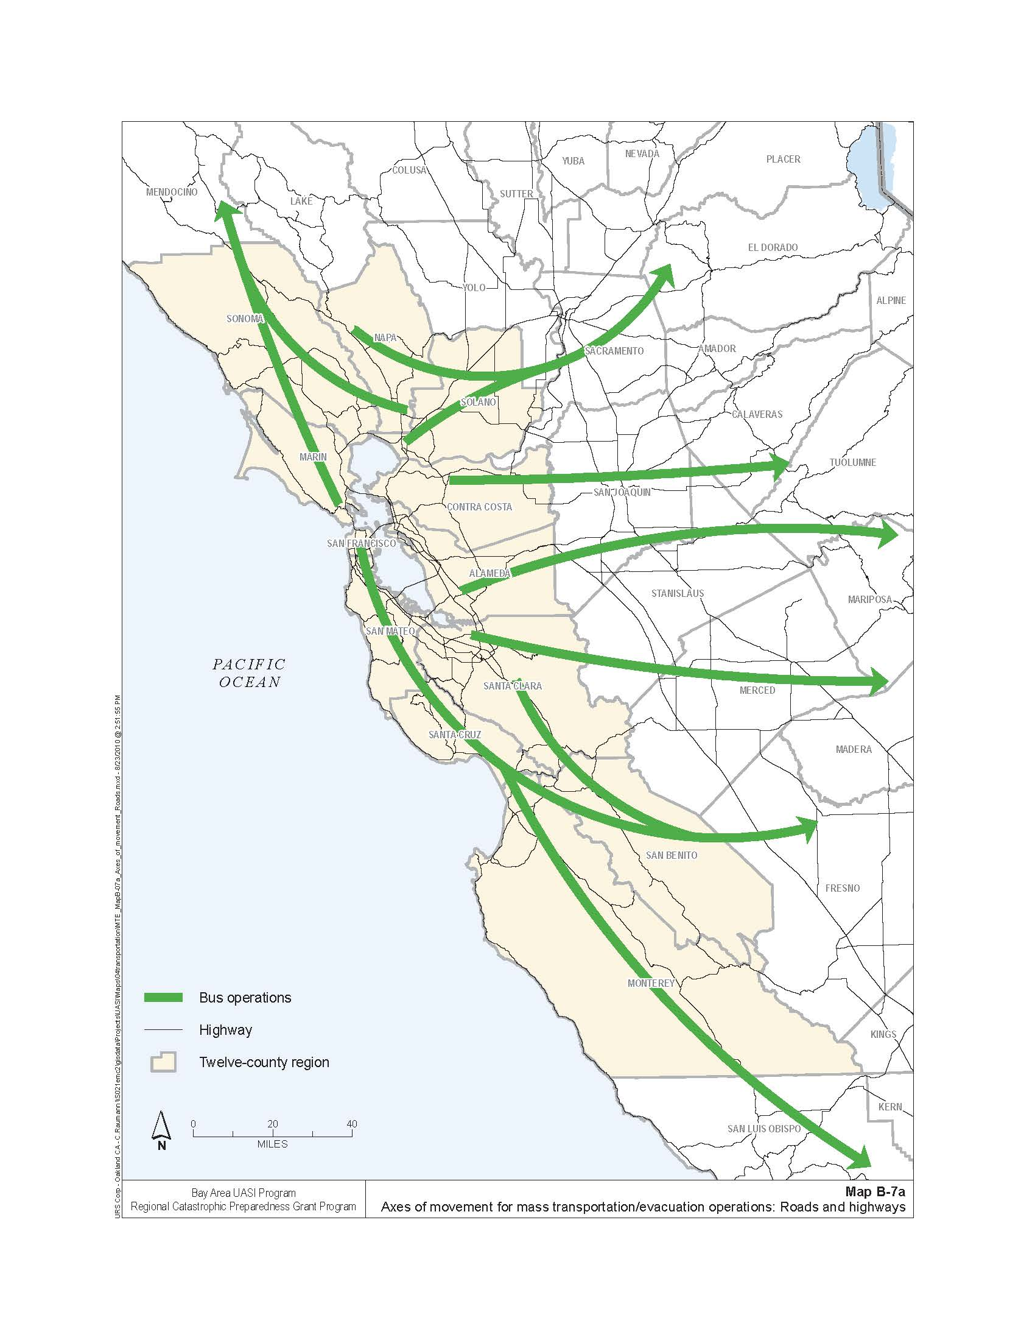

*Reference: Regional Catastrophic Earthquake Mass Transportation/Evacuation Plan*

*Annex to the San Francisco Bay Area Regional Emergency Coordination Plan*

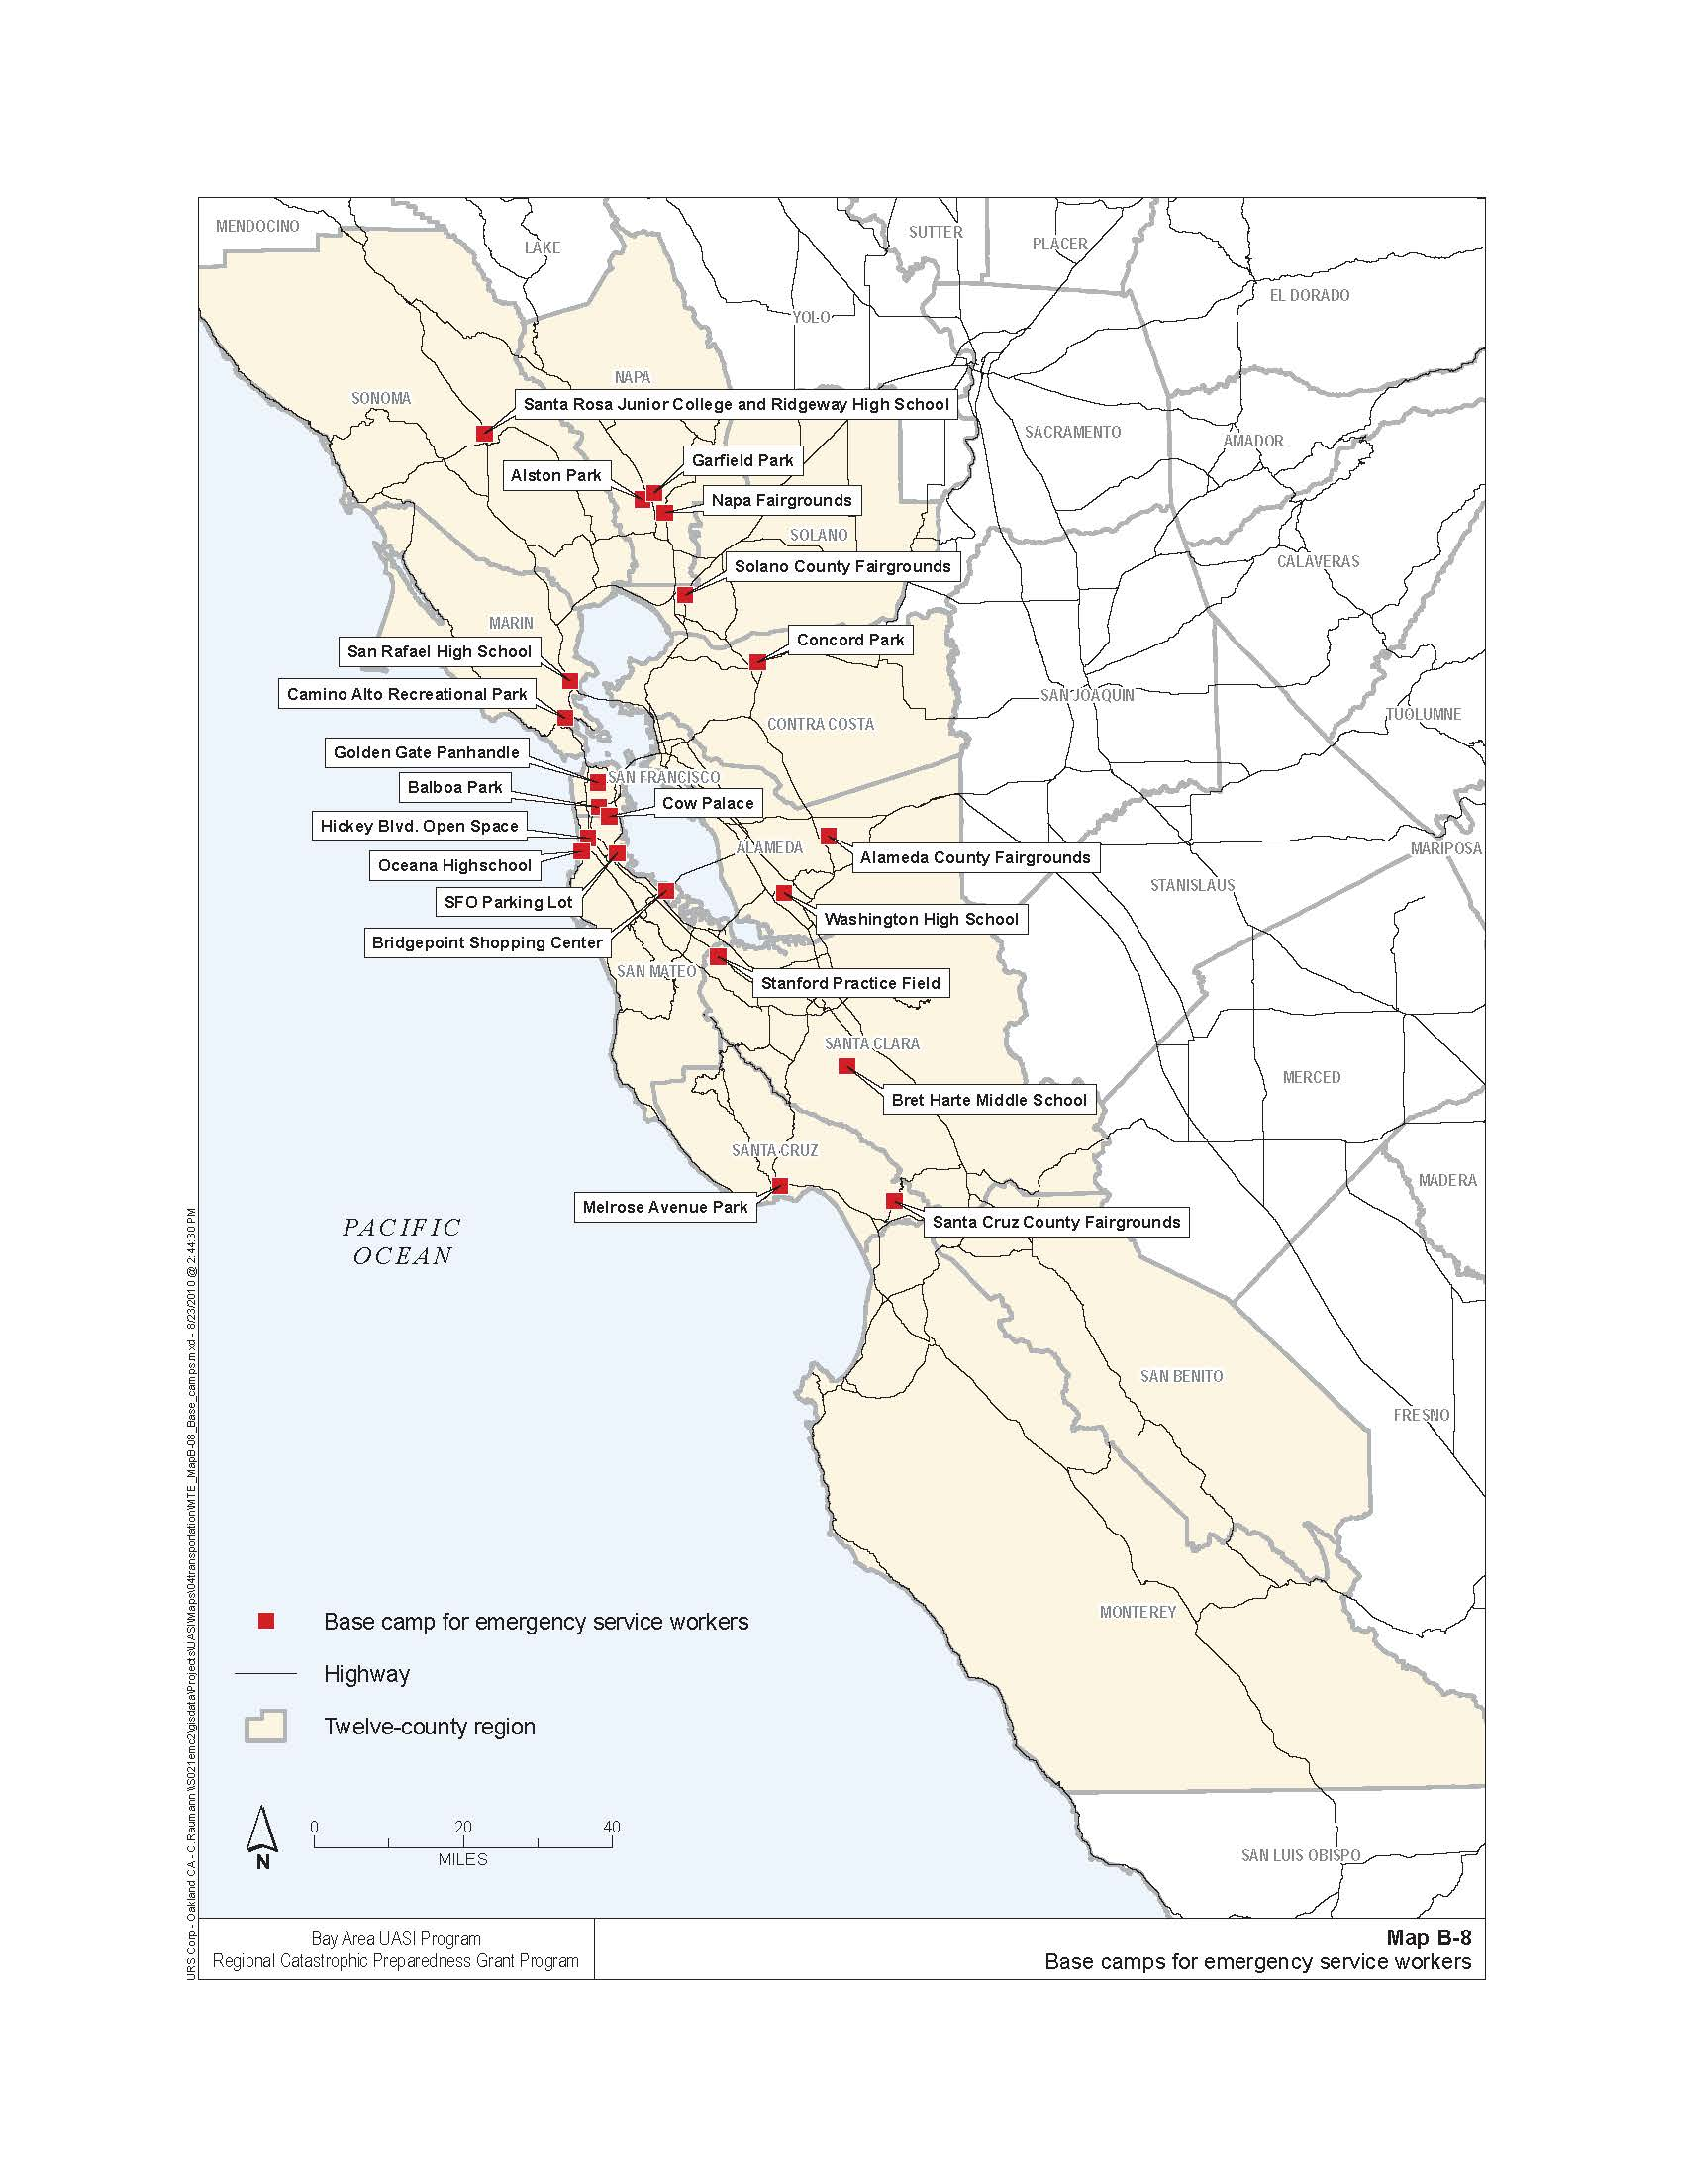

*Reference: Regional Catastrophic Earthquake Mass Transportation/Evacuation Plan*

*Annex to the San Francisco Bay Area Regional Emergency Coordination Plan*

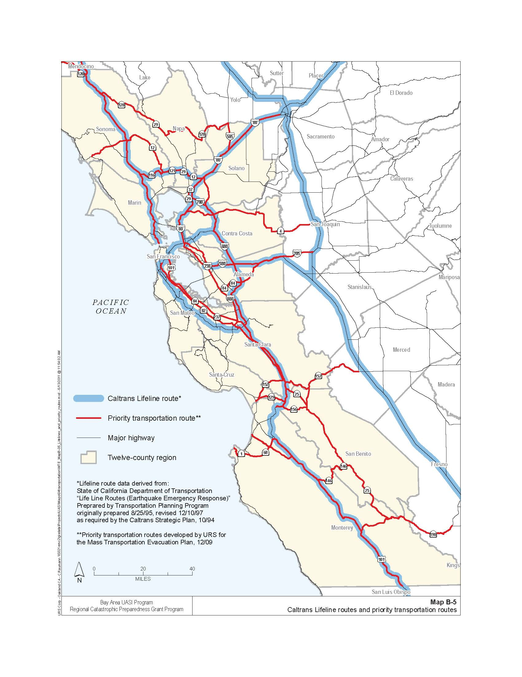

*Reference: Regional Catastrophic Earthquake Mass Transportation/Evacuation Plan*

*Annex to the San Francisco Bay Area Regional Emergency Coordination Plan*

APPENDIX F: Discussion Questions

The following questions are provided as suggested subjects that you may wish to address as the discussion progresses. These questions are not meant to constitute a definitive list of concerns to be addressed, nor is there a requirement to address every question.

1. How many people will you need to serve with the POD resources?
2. What type of POD is necessary in your Op Area?
3. Describe some scenarios that would require activation of PODs within the Bay Area. What are some triggers for activating PODs?
4. Where will the POD(s) be located? What is the process for determining potential POD sites? Who makes this determination? What role do site owners have in this process?
5. Have agreements been put in place with property owners? Do other plans exist to use the property for another purpose that would conflict with its use as a POD?
6. How is the type of commodities to be distributed determined? Who makes this determination? How is this communicated to internal and external stakeholders?
7. Who makes the decision to activate PODs? What is the process for activating PODs?
8. How is the decision to activate the PODs communicated to site owners? Who maintains contact information for POD site owners? Is this information accessible and updated?
9. What are the OA’s roles and responsibilities for activating PODs? What are the site owners’ roles and responsibilities for activating PODs? What are the initial actions for establishing POD sites?
10. What is the process for notifying staff of POD activation? Who is responsible for notifying staff of POD activation?
11. From your perspective, identify and describe the challenges associated with activating POD sites.
12. What resources are available to staff and manage the POD(s)?
13. What resources are necessary for the establishment of vehicle POD sites? What resources are necessary for the establishment of pedestrian POD sites?
14. Who is responsible for providing staffing and other resources at established PODs?
15. What is the process for providing commodities to the PODs for distribution? How are commodities transported to PODs sites? Will any POD commodities or supplies be stored at the sites?
16. Describe some issues related to security at established POD sites. Who is responsible for providing security at POD sites?
17. How will traffic be managed at established POD sites? Who coordinate traffic management resources for POD sites?
18. Describe the process for informing the public of POD activation and operation.
19. How will the public be alerted to the activation of POD sites?
20. Who has the responsibility for informing the public of POD operating hours and processes?
21. What coordination will take place between the city and site owners regarding public information?
22. How will commodity distribution address individuals with access and functional needs?
23. How will the operation of a POD affect normal operations at the site?