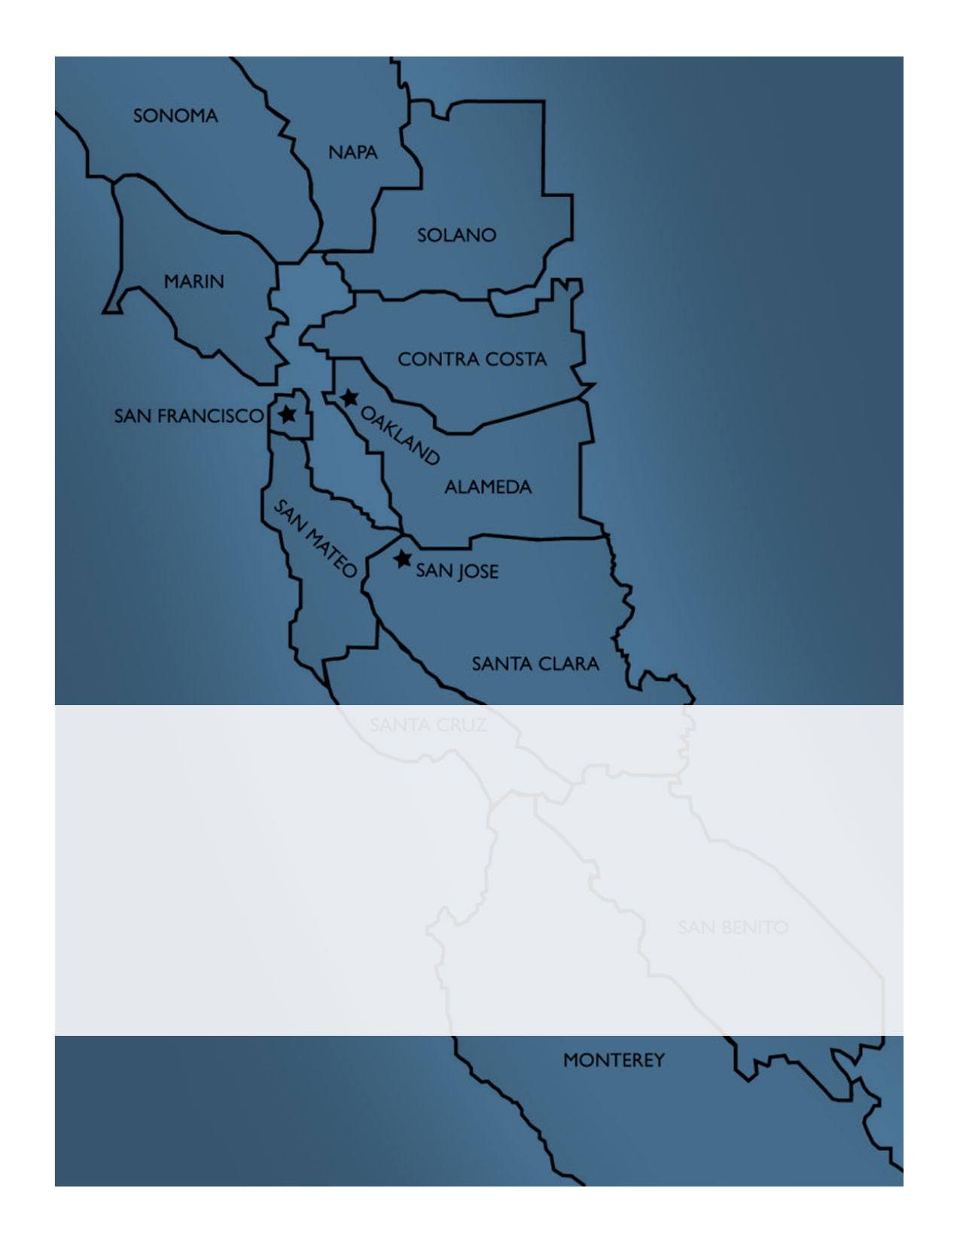
February 2018

The Bay Area Joint Information System (JIS):
A Framework for Coordinating Public Information and Warning throughout the
San Francisco Bay Area

Record of Changes

The most current copy of this document, including any changes, is available on the Bay Area Joint Information System shared document repository and via email at bayareajis@gmail.com.

Version | Date of Change | Summary of Change(s) | Name/Title | Agency/ Organization
1.0 | 2/26/18 | Version 1.0 finalized | Corinne Bartshire, Program Manager | Bay Area UASI

Table of Contents
Record of Changes 2
Letter of Commitment 4
I. Overview 6
II. Authority 8
III. Purpose 10
IV. Planning Considerations 11
V. Concept of Operations 12
Coordination for Non-Emergency Events 12
Emergency Coordination 13
Examples of Joint Information System Coordination Activities 14
V. Roles and Responsibilities 18
Coordination for Non-Emergency Events 18
Emergency Coordination 19
VI. Maintenance 23
Additional Joint Information System Resources 24

The Bay Area Joint Information System Framework and accompanying Toolkit were developed with funding from the Bay Area Urban Areas Security Initiative.

Letter of Commitment

Public information and warning is a critical emergency management capability and an inherent responsibility of local, state, and federal government. Communicating with the public and other stakeholders before, during, and in the aftermath of an emergency can save lives, property, and the environment.

Timely, accurate, accessible, and consistent public information is contingent on the ability of jurisdictions throughout the Bay Area region to coordinate information, resources, and messaging about an emergency. The Bay Area Joint Information System is a network of individuals with responsibilities to support emergency public information and warning. Members come together from a broad spectrum of agencies, disciplines, and jurisdictions throughout the Bay Area to work together to coordinate public information and warning efforts before, during, and after emergencies.

The system is led by a Leadership Committee with representation from each of the twelve Operational Areas and two Core Cities in the Bay Area region. Committee members commit to serving a minimum of one year terms, ensure their role and contact information is shared with public information staff within their Operational Area or Core City, and are responsible for onboarding new Joint Information System members and Committee representatives.

Representatives from Bay Area jurisdictions across the Bay Area contributed to the development of the Bay Area Joint Information System Framework. Dozens of members of the Joint Information System provided insight and guidance at workshops and trainings to inform the concepts outlined in this document.

The Framework outlines the general structure and operations of the Bay Area Joint Information System. This Framework is consistent with the California Standardized Emergency Management System (SEMS) and National Incident Management System (NIMS). Members recognize that by implementing this Framework and committing to coordinating public information efforts across the Bay Area, emergency public information will be more timely, accurate, accessible, and consistent than it might be if any one jurisdiction worked independently.

While no system or document can completely prevent death and destruction, public information and warning coordination carried out by knowledgeable and well-trained individuals can and will minimize losses. The members of the Bay Area Joint Information System Leadership Committee give their full support to this plan and urge all officials, employees and the residents, individually and collectively, to support the Bay Area Joint Information System.

Joint Information System 2018 Leadership Committee
Tya Modeste | Alameda County
Betsy Burkhart, Co-Chairperson | Contra Costa County
Laine Hendricks | Marin County
Maia Carroll and Karen Smith | Monterey County
Kristine Jourdan | Napa County
Dena Gunning | City of Oakland
Brian LaSota | San Benito County
Francis Zamora | City and County of San Francisco
Cheryl Wessling | City of San Jose
Michelle Durand, Co-Chairperson | San Mateo County
Patty Eaton | Santa Clara County
Jason Hoppin | Santa Cruz County
Matthew Davis | Solano County
 | Sonoma County

I. Overview

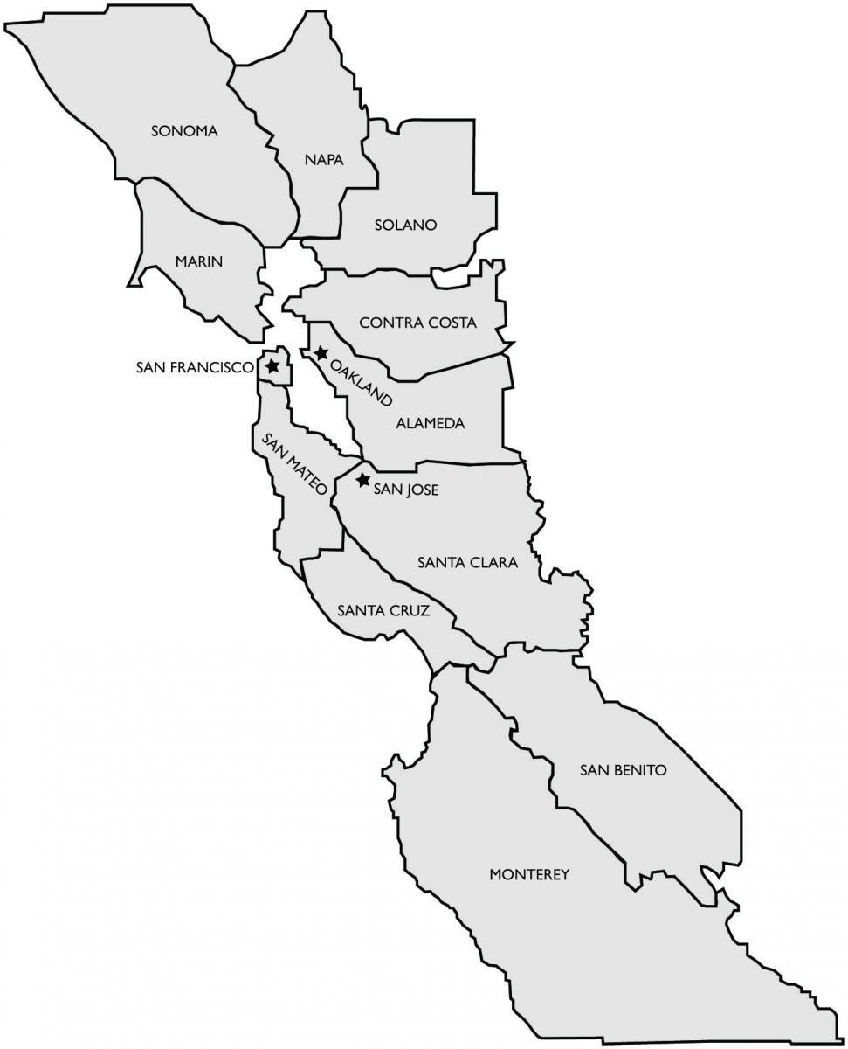
The Bay Area Joint Information System is a network of individuals with emergency public information and warning responsibilities from multiple agencies, disciplines, and jurisdictions throughout the Bay Area. Bay Area Joint Information System members work together to coordinate public information and warning efforts before, during, and after emergencies.
Figure 1. Bay Area Joint Information System Regional Footprint

The Bay Area is an expansive, diverse region. It includes twelve Operational Areas, three core cities, and hundreds of local jurisdictions. The drive from Santa Rosa (Sonoma County) to Salinas (Monterey County) can easily take four hours. The region is served by two major media markets and many of the world’s most popular social media companies call the Bay Area home. In addition to the most frequently heard English, Spanish, Chinese, Tagalog, and Vietnamese, tens of thousands of residents speak more than 100 other languages.

Although the region spans a sizeable area, its jurisdictions are connected by shared hazards (earthquakes, flooding, and terrorism, to name a few) and roadways (such as Highway 1 or 101). Thousands of residents live in one Operational Area and commute daily for work, shopping, entertainment, or recreation in another. Alerts or messages that one jurisdiction provides to the public in an emergency inevitably influence conversations in other parts of the region.

Because its residents are well-traveled, there is a culture of shared interests and a willingness to help each other. Joint Information System members have embraced coordinating across dozens of organizations and disciplines to share information and deliver accurate and consistent public information. In this spirit of mutual respect and collaboration, Joint Information System members help each other in multiple ways, whether de-conflicting messages across jurisdictions, sharing the results of information analysis, amplifying rumor control efforts, or providing mutual aid and shared resources to support local emergency public information activities.

As noted in California’s Standardized Emergency Management System, the Joint Information System works because it is flexible and adaptable to any type of event, emergency, or member request for support. There is no requirement for members to give more time or resources than they have available. Members also recognize that participation in the Bay Area Joint Information System – coordinating public information and sending clear, de-conflicted messages to the public – can save lives. That hope drives collaboration and continuous improvement.
Members recognize that their first priority and commitment is always to their respective jurisdictions and agencies.

II. Authority

The Bay Area Joint Information System is a voluntary network of twelve Bay Area Operational Areas, and their constituent jurisdictions, agencies, and organizations from across the region. Members manage and operate the system. There is no fee to join or become a member.

Member jurisdictions acknowledge that by implementing this Framework and committing to coordinating public information efforts across the region, emergency public information will be more timely, accurate, accessible, and consistent than it might be if they worked independently. In members’ own words (Figure 2), the Joint Information System is a “web of relationships,” “a place to access information and shared resources.”
Figure 2. Benefits of the Bay Area Joint Information System
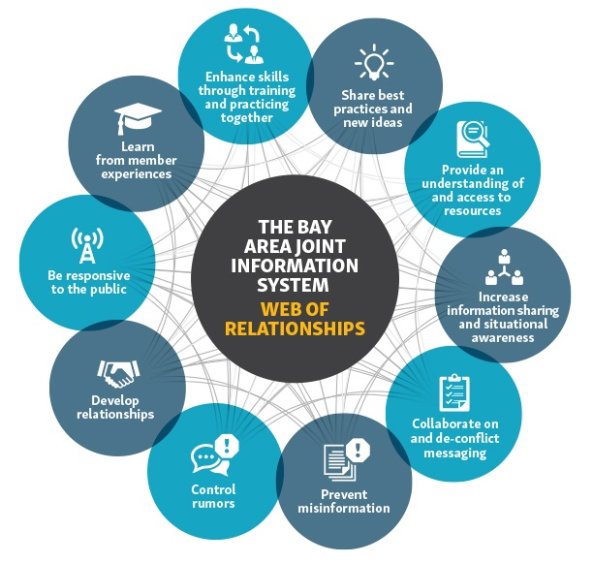

This Framework has been prepared in accordance with the standards of the National Incident Management System and the California Standardized Emergency Management System. Joint Information System members from the Bay Area Operational Areas and the cities of San Jose and Oakland, along with dozens of additional local government jurisdictions, agencies, non-profit, and private sector organizations contributed to the development of this Framework.
Member jurisdictions and organizations are encouraged to follow their own processes and policies for adoption of this Framework.
Adopting this Framework at the local government level; and committing to continued support and integration with the Joint Information System enables the region to be successful in achieving the Joint Information System’s purpose.

III. Purpose

The purpose of this Framework is to provide an overview of activities, structure, and roles for how the Bay Area Joint Information System will coordinate and collaborate before, during, and after an event or emergency.
Definitions
Emergency – Whether a single incident (such as a fire) or large-scale regional disaster (such as an earthquake or epidemic), emergencies threaten life safety, property, and/or the environment. Emergencies typically limit our ability to perform our normal, day-to-day functions, so we rely on emergency organizational structures, operations plans, policies, and training.

Event – A planned, non-emergency activity. Examples include sporting events, lectures, parades, and festivals.

The Framework is organized by:
- Overview of the Joint Information System – describes the scope of the Bay Area region and why the Joint Information System is important.
- Purpose - includes the purpose of the Framework and provides an overview of its contents.
- Planning Considerations – contains a list of assumptions that remain constant and form the basis for the Framework.
- Overview of Joint Information System Activities – acknowledges that coordination within the Joint Information System occurs for both emergencies and non-emergency events. This section describes different types of coordination.
- Roles and Responsibilities – lists the primary roles and responsibilities in the Joint Information System (including responsibilities of members, the Leadership Committee, and the Regional Joint Information System Coordination Team)

IV. Planning Considerations

The following list includes assumptions that form the basis for the processes and structures in this Framework.

- Different from most Emergency Operations Centers or Joint Information Centers, the Bay Area Joint Information System is always active. Members continuously operate within the Joint Information System structure.
- Joint Information System coordination occurs for non-emergency activities, such as planned events or exercises; for emergencies that occur with or without notice; and, following an emergency as members begin to transition back to normal operations.
- Natural and human-caused disasters can occur with or without warning, at any time of the day or night, and can affect one or more Operational Areas within the Bay Area.
- The succession of events in an emergency is not predictable. Bay Area Joint Information System activities will depend on the nature and demands of the emergency and the needs of the Joint Information System members.
- Although there are many similarities among the Operational Areas in the Bay Area, each one is unique with its own emergency management programs and plans. The authority outlined in approved state and local emergency management plans and policies supersedes the processes or guidance in this Framework.
- This Framework outlines a structure and processes to support coordination. It establishes a foundation for the Joint Information System through a set of guiding concepts and principles, rather than a more formal plan, to allow for the regional Joint Information System to evolve and adapt to its members’ specific needs.
- Joint Information System members follow their local processes and agreements for mutual aid.
- Activities to support regional coordination are not reimbursable outside of formal mutual aid agreements.
- Unique circumstances of an emergency may prevent the implementation of Framework components, or require actions that are significantly different from those described in the Framework.
- All Bay Area jurisdictions – and the Bay Area Joint Information System – align with the systems, concepts, and structures in the California Standardized Emergency Management System.
- Bay Area Joint Information System members are responsible for maintaining positive working relationships, open communication, and active coordination before, during, and after an emergency.

V. Concept of Operations

This section provides an overview of Joint Information System activities, whether for non-emergency events or to support regional coordination during an emergency response.

Coordination for Non-Emergency Events

Bay Area Joint Information System members work together to prepare for, mitigate, prevent, and protect the region from emergencies. Examples of non-emergency activities include:
- Hosting or attending workshops, meetings, and trainings on emergency public information and warning
- Hosting or attending networking gatherings to get to know other Joint Information System members
- Sharing information on or inviting other members to participate in local preparedness campaigns
- Sharing local public information and warning plans and tools
- Supporting local exercises as evaluators or observers
- Participating in regional exercises or planned events to practice Joint Information System coordination

A Joint Information System member who would like to reach the Joint Information System for support or participation for an upcoming activity has multiple options:
- Contact other member(s) directly or as a group using virtual coordination platforms or the Joint Information System Listserv
- Contact the Joint Information System Leadership Committee member representing the Operational Area or Core City

Emergency Coordination

When an emergency occurs, Bay Area Joint Information System activities may include:
Verifying Information
Joint Information System members are expected to verify information before sharing it with other members as situational awareness (or clearly indicate when information is not yet confirmed). It is a best practice for the Lead Public Information Officer or liaison to the Joint Information System to confirm their information with the Public Information Officers and/or Incident Commander in the field and/or the appropriate section in their Emergency Operations Centers. Public Information Officers should refer to their local plans for verification procedures.
- Sharing Situational Awareness (e.g., providing updates on individual jurisdictions’ public information activities) (Also see the text box on Verifying Information.)
- Message collaboration (e.g., sharing messages and whenever possible, working together to de-conflict messages before they are disseminated to the public)
- Social and traditional media monitoring (e.g., sharing information about trending topics, misinformation, and rumors)
- Coordinating strategies to address trends and misinformation (e.g., brainstorming and sharing ways to address trending topics and misinformation. A coordinated approach to rumor control is crucial to ensure media confidence in response efforts and avoid information conflicts.)
- Sharing written products (e.g., this may include sharing news releases, talking points, and fact sheets with Joint Information System members or providing support drafting materials for other jurisdictions overwhelmed by the demands of the emergency)
- Mutual Aid Support (the Joint Information System leadership does not fill mutual aid requests, but they may have ideas for the types of mutual aid that affected jurisdictions may want to consider; and/or have suggestions for members with the availability and experience to fill requests)
- Media Management (e.g., coordinating responses to media inquiries – especially those that have the potential to affect another jurisdiction, ensuring that media are directed to the correct entities)
- After-Action Reporting (e.g., providing feedback on coordination, evaluating and implementing corrective actions as appropriate)

Joint Information System coordination will depend on the level and type of emergency. Different types of emergency events may include:
- Operational Area Level – an event that affects one Operational Area that is able to respond with limited outside assistance
Outside of formal mutual aid agreements, activities that support regional Joint Information System coordination are not reimbursable.
- Regional Level – an event that affects multiple Operational Areas in the Bay Area and involves an Emergency Declaration by the Governor
- Catastrophic Level – an event that overwhelms the capability of the region, involves an Emergency Declaration by the Governor, as well as resources mobilized by the Federal Government

Examples of Joint Information System Coordination Activities

The following table (Table 1) provides examples of ways that the Joint Information System may coordinate public information and warning efforts during non-emergencies and different levels of emergencies. Actual Joint Information System activities will depend on the demands of the event or emergency, as well as requests for support from an affected jurisdiction.

Table 1. Examples of Joint Information System Coordination Activities
Activity | Non-Emergency | Operational Area Level | Regional Level | Catastrophic Level | Recovery
Situational Awareness | - Share public information and warning efforts as they relate to emerging hazards, threats, mitigation efforts, upcoming events, etc.  - Share best practices, lessons learned and new trends/standards in public information and warning | - Verify and share information about public information and warning response activities for evolving incidents that have the potential to impact other Operational Areas  - Monitor and share status updates on virtual coordination platforms | - Identify a Joint Information System Liaison (who is also a staff member of the local Joint Information Center, if activated) to verify and share information with the Joint Information System  - Gather information from most heavily affected Operational Areas  - Monitor and share status updates on virtual coordination platforms | - Identify a Joint Information System Liaison (who is also a staff member of the local Joint Information Center, if activated) to verify and share information with the Joint Information System  - If the Joint Information System is convening in a physical location, provide a liaison to co-locate with other Joint Information System representatives  - Monitor and share status updates on virtual coordination platforms  - Verify and share information with the state, federal and other California regional and private sector partners | - Conduct or participate in after action debriefs to share best practices and lessons learned, and identify improvements to the Joint Information System
Media Management | - Conduct joint press conferences and other joint media events and availabilities to help build relationships  - Co-host media coffees or other networking events to talk about regional coordination with the media | - Share information about emerging stories or media inquiries with the potential to impact other Operational Areas  - Redirect media inquiries to appropriate Operational Areas as needed | - Coordinate press conference scheduling to avoid timing conflicts  - Support technical logistics for virtual joint press availabilities  - Support affected Operational Areas by answering media lines | - Assist with coordination for joint press conferences  - Support technical logistics for virtual joint press availabilities  - Staff a media hotline and help direct inquiries to appropriate Operational Area(s)  - Coordinate media inquiries with the State/Federal Joint Information Center, if activated | - Advise Joint Information System members when local Joint Information Centers and/or media hotline are demobilized  - Provide contact info for future inquiries so Joint Information System members can refer media to appropriate contacts if requested
Media/Social Media Monitoring | - Like/follow other Joint Information System member jurisdictions, media, and other influencers on social media  - Maintain daily monitoring activities for own jurisdiction | - Monitor own social media account for inquiries or concerns from users who may be affected by an emergency in another Operational Area, or concerned about the effects of the emergency in your jurisdiction | - Coordinate media/social media monitoring efforts and share trending hashtags, questions, concerns, rumors, themes etc. | - Coordinate media monitoring efforts and support rapid response to rumor control activities | - Maintain monitoring activities for own Operational Area throughout recovery
Activity | Non-Emergency | Operational Area Level | Regional Level | Catastrophic Level | Recovery
Message Development and Coordination | - Share preparedness, mitigation, prevention and protection messages  - Share preparedness campaign materials and activities  - Develop joint messaging  - Review and update messaging templates | - Affected jurisdiction shares messaging about emergency and response with Joint Information System | - Coordinate messaging (before release, if possible) to avoid conflicts among Operational Areas | - Coordinate messaging (before release, if possible) to avoid conflicts among Operational Areas  - Coordinate messaging with the State/Federal Joint Information Center, if activated | - Coordinate messaging on recovery and deactivation with Joint Information System
Message Distribution | - Share/retweet posts with messages about preparedness, mitigation, prevention and protection from other Joint Information System members  - Notify other jurisdictions when testing alert notification systems  - Share alert notification message templates internally and with other Operational Areas | - Share/retweet posts from affected Operational Areas  - Notify other Operational Areas when sending alert notification messages | - Coordinate alert notification messages  - Coordinate consistent use of social media hashtags  - Share/retweet posts from affected Operational Areas  - Coordinate alert notification messages | - Coordinate alert notification messages  - Coordinate non-traditional messaging (e.g., leveraging community door-to-door teams when communications infrastructure is compromised)  - Coordinate messaging with the State/Federal Joint Information Center, if activated | - Coordinate messaging on where media and the public should find information during recovery

Activity | Non-Emergency | Operational Area Level | Regional Level | Catastrophic Level | Recovery
Mutual Aid | - Inventory public information resources that may be offered to support mutual aid in an emergency  - Share inventory with Mutual Aid Coordinator (Leadership Committee) and your local Emergency Operations Center | - Request mutual aid from Emergency Operations Center to provide public information support to affected Operational Areas  - Inform the Regional Joint Information System Coordinator and/or Mutual Aid Lead of requests for mutual aid (they do not fill requests, but they may have suggestions for members with the necessary skills and experience) | - Request mutual aid from Emergency Operations Center to provide public information support to affected Operational Areas  - Inform the Regional Joint Information System Coordinator and/or Mutual Aid Lead of requests for mutual aid (they do not fill requests, but they may have suggestions for members with the necessary skills and experience) | - Mutual aid support may come from agreements with the State and other California regions. | - Continue to request mutual aid as needed  - Update mutual aid agreements based on best practices and lessons learned  - Update mutual aid inventories to reflect lessons learned
Admin/ Maintenance | - Maintain relationships and operational readiness through regional training and exercise opportunities  - Implement the Joint Information System for planned events  - Welcome and onboard new members  - Maintain Joint Information System Listserv  - Continuously use virtual coordination platforms to share information | - Document any Joint Information System activities  - Facilitate information sharing between affected and un-affected Operational Areas (especially on virtual coordination platforms ) | - Document mutual aid activations  - Support utilization of virtual coordination platforms for regional coordination | - Facilitate coordination with state, federal and other California regional and private sector partners  - Document mutual aid activations  - Support utilization of virtual coordination platforms for regional coordination | - Document best practices and lessons learned  - Support utilization of virtual coordination platforms for regional coordination  - Participate in after-action reporting  - Support implementation of corrective actions

V. Roles and Responsibilities

This section describes the general roles and responsibilities that support Joint Information System operations and activities.

Coordination for Non-Emergency Events

Joint Information System Members

The Bay Area Joint Information System is a network of individuals with responsibilities to support emergency public information and warning. Members come together from a broad spectrum of agencies, disciplines, and jurisdictions throughout the Bay Area to work together to coordinate public information and warning efforts before, during, and after emergencies. In general, member responsibilities include:
- Identifying and reaching out to the Operational Area or Core City representative on the Joint Information System Leadership Committee
- Reviewing/understanding how to implement the Bay Area Joint Information System Framework and supporting tools
- Signing up and regularly using Joint Information System virtual coordination platforms to share information about upcoming events, activities, preparedness campaigns, local plans, interesting articles, best practices, etc.
- Developing relationships with fellow Joint Information System members
- Following other Joint Information System members in the media and on social media
- Hosting or participating in training and exercise opportunities to practice regional coordination
- Participating in regular Joint Information System conference calls
- Participating in after-action reporting efforts, as appropriate

Joint Information System Leadership Committee

Day-to-day, the system is led by a Leadership Committee. (See Figure 3 for a Leadership Committee organizational chart.) Ideally, the Committee includes representation from each of the twelve Operational Areas and two Core Cities in the region (14 members total). When regional representation is not feasible, the Committee Co-Chairs seek volunteers from other member agencies and organizations to fill vacant positions. Leadership Committee members serve one-year terms and perform leadership functions that cover:
- Chairperson (e.g., co-chairpersons coordinate the overall functions of the Joint Information System)
- Documentation (e.g., after-action reporting, document management and maintenance, etc.)
- Technology (e.g., managing participation on virtual coordination platforms)
- Listserv (e.g., managing use of the Joint Information System Listserv)
- Training and Exercising (e.g., encouraging participation in local/regional opportunities)
- Monthly Calls (e.g., facilitating a monthly call for members to connect and share information)
- Mutual Aid (e.g., maintaining an awareness of skills/experience/availability of public information and warning staff in the Bay Area)

Participation in the Joint Information System is voluntary for all members, including members serving in leadership roles. Committee members are responsible for the ongoing maintenance of and continuous improvements to the Joint Information System.

Figure 3. Bay Area Joint Information System Leadership Committee
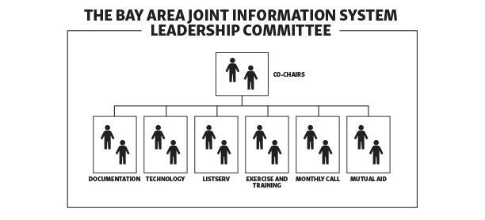

State Public Information Officer
California Governor’s Office of Emergency Services’ State Public Information team may provide training to Joint Information System members on public information and warning best practices and regional coordination.

Emergency Coordination

Joint Information System Members

In an emergency, member responsibilities may include:
- Designating a Joint Information System Liaison to facilitate coordination between the Joint Information System and local Emergency Operations Center and/or Joint Information Center
- Notifying the Regional Joint Information System Coordinator of status (especially if local Joint Information Center is activated)
- Use virtual coordination platforms to share information and monitor for situational awareness
- Determining whether mutual aid is needed or can be provided to support local or regional emergency public information and warning
- Coordinating messaging and outreach to public/media with other affected Joint Information System members
- Participating in Regional Joint Information System Conference Calls

Joint Information System Liaison

The Joint Information System Liaison is a part of a local jurisdiction’s Emergency Operations Center and/or Joint Information Center organizational structure. The Liaison is responsible for coordination between the Bay Area Joint Information System and a jurisdiction’s Lead Public Information Officer/Joint Information Center or equivalent. The Joint Information System Liaison supports informed decision-making and overall coordination efforts led by the Lead Public Information Officer. The Liaison also works across Joint Information Center (or equivalent) functions to ensure that the jurisdiction is collaborating with agencies and organizations throughout the Bay Area on emergency public information. The Liaison most often communicates with other Joint Information System members via the system’s online coordination tools and conference calls.

Regional Joint Information System Coordinator

For an emergency, one of the Joint Information System Leadership Committee Co-chairpersons serves as or designates a Regional Joint Information System Coordinator.

Broadly, Regional Joint Information System Coordinator responsibilities may include:
- Maintaining regional visibility into public information and warning response or recovery efforts
- Identifying suggestions for how the Joint Information System can support affected jurisdictions
- Facilitating conversations among affected and non-affected jurisdictions, including conversations to coordinate message development and dissemination
- Managing situational awareness across the Joint Information System
- Facilitating Regional Joint Information System conference calls to brainstorm solutions to regional public information and warning challenges
- Liaising with the State Public Information Officer to share information about regional coordination
Participation on the JIS Coordination Team is voluntary until participants put in place formal agreements and/or methods of reimbursement.
Regional Joint Information System Coordination Team
Coordination Team members coordinate and provide support outside of formal mutual aid processes. Depending on the demands of the emergency, the Regional Joint Information System Coordinator may mobilize a Regional Joint Information System Coordination Team to support Joint Information System coordination activities. (See Figure 4 for a diagram of the Coordination Team.)

Figure 4. Bay Area Joint Information System Coordination Team
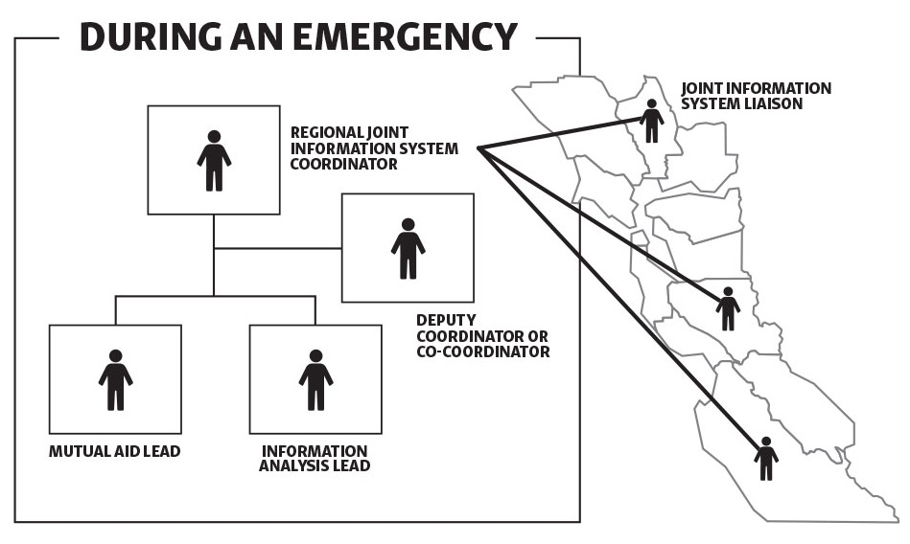

The Regional Joint Information System Coordinator and/or Leadership Committee members may call on Joint Information System members to serve on the Coordination Team in one or more of the following functions. The Coordinator shares team contact information with other members via the Joint Information System Coordination Tools.
- Co-Coordinator or Deputy
  - Share responsibilities or support the Regional Joint Information System Coordinator as assigned
- Information Analysis Lead
Either performed by the Joint Information System Leadership Committee’s Technology Coordinators or coordinating with those individuals when possible.
  - Support continuous engagement, information sharing, and information analysis on the Joint Information System virtual platforms
  - Monitor and support member engagement on virtual coordination platforms
  - Gather valuable information from members’ posts and summarize the information so it is useful to the Joint Information System members
- Mutual Aid Lead
Either performed by the Joint Information System Leadership Committee’s Mutual Aid Coordinators or coordinating with those individuals when possible.
  - Provide ideas for what types of public information and warning mutual aid affected jurisdictions may want to consider for current or future operational periods
  - Suggest Joint Information System members with the necessary skills and experience to fill mutual aid requests
  - Work within his or her own emergency management structures and processes to monitor requests for public information mutual aid

State Public Information Officer
In an emergency, the State Public Information Officer coordinates with the Bay Area Joint Information System Coordinator and works directly with Public Information Officers from affected jurisdictions as needed.

The State Public Information Officer may provide support with the following:
- Coordinating public information and warning-related information sharing, messaging, and resource requests across California state agencies
- Identifying personnel from other parts of the state who have specific training, skills, and experience to support emergency response or recovery efforts in the Bay Area
- Serving in positions on the Bay Area Joint Information System Coordination Team or in local Joint Information Centers, as requested by affected jurisdictions (e.g., in a catastrophic emergency)
- Providing analysis and/or tools to support public information and warning, such as media summaries, sample messages, etc.

VI. Maintenance

The Joint Information System Leadership Committee is responsible for the ongoing implementation and maintenance of the regional system, including annual reviews and updates to this Framework and accompanying tools, maintenance of virtual coordination tools, and evaluating and implementing improvements.

Near the end of their term of service, Leadership Committee members are also responsible for transitioning their duties to new members who will represent their Operational Area or jurisdiction on the Leadership Committee.

Additional Joint Information System Resources

Members may reference the following resources and tools to support the activities of the Bay Area Joint Information System. To request access to these resources, email bayareajis@gmail.com.

- Bay Area Joint Information System Toolkit
The toolkit provides checklists, worksheets, and other resources to support the implementation of the Bay Area Joint Information System.

- Bay Area Joint Information System Google Drive
The Google Drive folder is an online shared document repository with copies of plans, messaging tools and templates, contact lists, and other information that may be useful to Joint Information System members.

- Bay Area Joint Information System Google Calendar
Bay Area Joint Information Systems members use the online shared calendar to share information about upcoming regional and local public information-related opportunities and events.

- Bay Area Joint Information System Google Group
The Google Group is an email listserv where the Bay Area Joint Information System where members exchange information about events and activities, request support on preparedness activities, and discuss topics related to public information and warning with other members.

In California, “Each county is designated as an operational area. An operational area may be used by the county and the political subdivisions comprising the operational area for the coordination of emergency activities and to serve as a link in the communications system during a state of emergency or a local emergency.” California General Code § 8605
Email bayareajis@gmail.com for access to the listserv and the Bay Area Joint Information System document repository.

